Virtual Visits

Virtual visits only require a few simple steps. The first is to take 5 pictures that can be assessed for growth and progress. Below are step-by-step instructions as to how to capture the correct images and where to send them. Once sent, the doctor will review them and a member of our team will contact you within 1-2 business days. Should you have any questions, please contact the office 123-457-7890 or info@doctor.com and we are happy to help!
1

TAKE PHOTOS

The easiest way to capture these photos is using your cell phone and a pair of spoons to help get your cheeks and lips out of the way. Below are examples of what the photos should look like.
2
#1 Front View |  | #2 Right View | #3 Left View
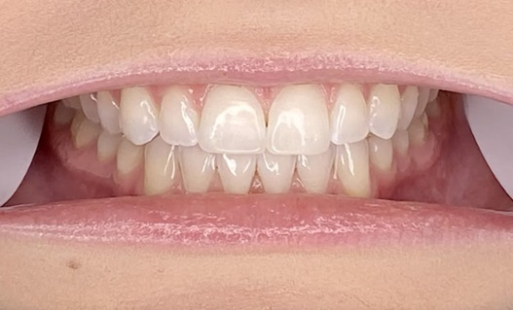 |  | 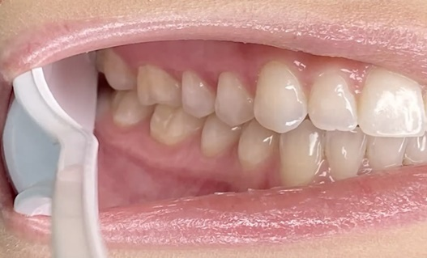 | 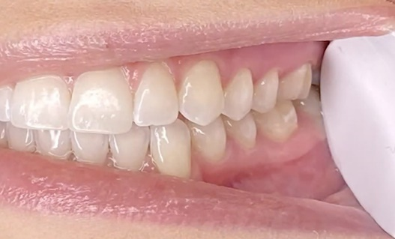
Bite down naturally with your back teeth touching. Directly face the camera, smile wide, click! Try to get as many teeth as you can in the picture. Pull your lips and cheeks away from your teeth with your fingers and/or spoons to show more teeth. |  | Bite down naturally with your back teeth touching. Use clean fingers and/or a spoon to pull back your cheek and lips to show all your back teeth on the RIGHT. Take a picture of your back teeth on the RIGHT. | Bite down naturally with your back teeth touching. Use clean fingers and/or a spoon to pull back your cheek and lips to show all your back teeth on the LEFT. Take a picture of your back teeth on the LEFT.
#4 Lower Teeth |  | #5 Upper Teeth
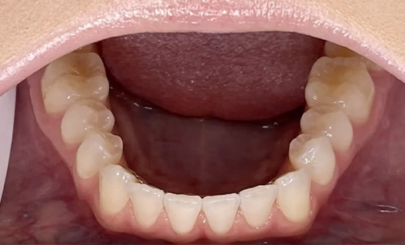 |  | 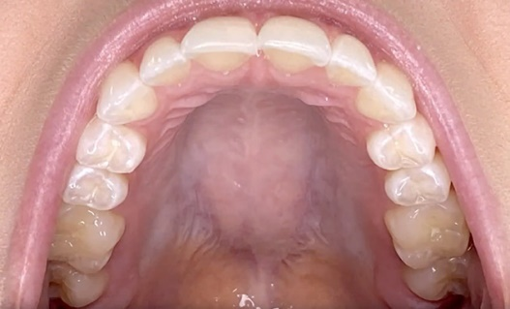
Open your mouth wide and tilt your chin downwards towards your chest. Hold the camera so that it’s as perpendicular as possible to the biting surfaces of your bottom teeth. Make sure all your teeth are showing and click! |  | Open your mouth wide and lift your chin as much as you can. Hold the camera so that it’s as perpendicular as possible to the biting surface of your top teeth. Make sure you can see all the teeth and click!
EMAIL PHOTOS

Emails your photos to info@doctor.com In the email subject, include the patient’s FULL NAME and DATE of BIRTH. A team member will be in touch with you within 1-2 business days with the next steps in the process.

