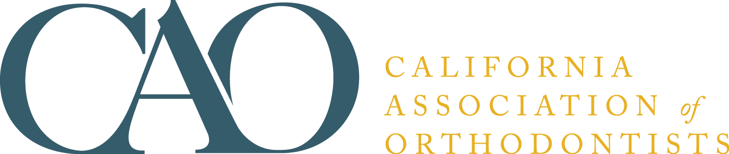

BROCHURE ORDER FORM

The CAO is proud to provide an assortment of brochures for orthodontic offices. These informative brochures are a helpful resource that are perfect to hand out to patients, parents, referring colleagues, etc. Additional information on the brochures are available at www.caortho.org.

Brochure pricing is as listed below; sales tax (if applicable) will be added to total. Minimum order is 50 booklets. Orders are shipped upon receipt of payment. Questions may be directed to info@caortho.org or (833) 226-2782.

PRODUCT | MEMBER PRICE | NON-AAO MEMBER PRICE | QUANTITY | TOTAL COST
Sleep Disordered Breathing (CHILD) | $25/50 brochures | $40/50 brochures
Sleep Disordered Breathing (ADULT) | $25/50 brochures | $40/50 brochures
You and Your Orthodontist (ENGLISH) | $75/50 brochures | $105/50 brochures
You and Your Orthodontist (SPANISH) | $75/50 brochures | $105/50 brochures
Smile…Now Let's See Your Bite (ENGLISH) | $65/50 brochures | $95/50 brochures
Smile…Now Let's See Your Bite (SPANISH) | $65/50 brochures | $95/50 brochures

Name __________________________________________ Phone _______________________

Address ________________________________________ Email ________________________

City/State/ZIP ___________________________________ County _______________________
(California Residents only)

Payment Method: MasterCard Visa American Express

Card # ______________________________ Expiration Date ______________ CVV# _______

Name as it appears on card _______________________________________________

Billing Zip Code ___________________

California Association of Orthodontists
15621 W. 87th St., #267 | Lenexa, KS 66219
(833) 226-2782 | Fax: (913) 845-4527 | info@caortho.org

