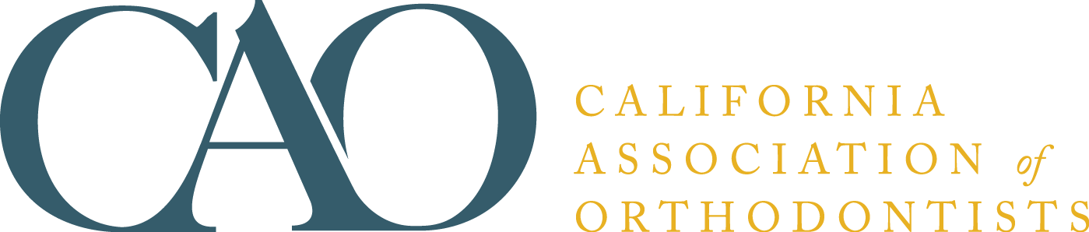

SLEEP DISORDERED BREATHING
Child and Adult Brochures

CAO is proud to announce the development of our brochures on sleep disordered breathing. More and more offices are beginning to see and treat patients that present with symptoms of sleep disorders or who have been diagnosed with sleep apnea.

These informative brochures are a helpful resource that will help explain signs and symptoms, risk factors and potential treatment options to patients, parents and are perfect for handing out to your referring colleagues.

Orders are shipped upon receipt. The cost is $25 per package of 50, plus sales tax (if applicable). Minimum order is 50 booklets. If you have questions, call the order department at (888) 242-3934.

ORDER FORM
Visit www.caortho.org to order online

Name _________________________________ Phone _______________________

Address ________________________________Email ________________________

City/State/ZIP ___________________________ County _______________________
(California Residents only)

Payment Method: ⁭MasterCard ⁭Visa ⁭American Express ⁭Bill me (members only)

Card # ______________________________ Expiration Date ______________ CVV# _________

Name as it appears on card _______________________________________________

PLEASE SEND ME _________ COPIES OF THE SLEEP DISORDERED BREATHING BROCHURES
SLEEP DISORDERED BREATHING in (check one) ____ Child ____ Adult Version
California Association of Orthodontists
401 N Lindbergh Blvd
St. Louis, MO 63141-7816
(888) 242-3934
Fax: (314) 993-6843
asebaugh@aaortho.org

