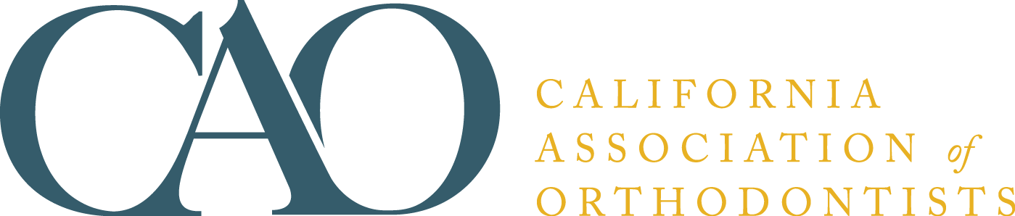

YOU AND YOUR ORTHODONTIST
Informed Consent for the Orthodontic Patient

Since 1983, we have provided our informed consent booklet to orthodontists around the world. Presently, almost 200,000 booklets are ordered on an annual basis. Most likely, the booklet is used in your community by orthodontists you know.

After an extensive re-write and review by orthodontists and legal counsel, we offer the most up-to-date and thorough informed consent material available. Much of the language now used in the booklet is more “patient friendly” and easier to read and understand.

Orders are shipped upon receipt. The cost is $150 per 100 for CAO/AAO members and $165 for non-members (pre-payment required for non-AAO members), plus sales tax (if applicable). Minimum order is 50 booklets. If you have questions, call the order department at (888) 242-3934.

ORDER FORM
Visit www.caortho.org to order online

Name _________________________________ Phone _______________________

Address ________________________________Email ________________________

City/State/ZIP ___________________________ County _______________________
(California Residents only)

Payment Method: ⁭MasterCard ⁭Visa ⁭American Express ⁭Bill me (members only)

Card # ______________________________________ Expiration Date ____________

Name as it appears on card _______________________________________________
________________________________________________________________________

PLEASE SEND ME _________ COPIES OF THE INFORMED CONSENT BOOKLET
YOU AND YOUR ORTHODONTIST in (check one) ____ English ____ Spanish ____Chinese
California Association of Orthodontists
401 N Lindbergh Blvd
St. Louis, MO 63141-7816
(888) 242-3934
Fax: (314) 997-1745
mnappier@aaortho.org

