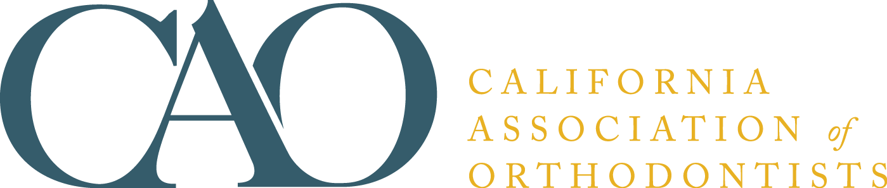

SMILE....Now Let’s See Your Bite
A parent’s guide to detecting bite problems

The California Association of Orthodontists SMILE kit is designed to help the public and referring dentist understand when an orthodontic exam is advisable. The kit has been field tested nationally and found to be simple to use and most effective; just tear off the ruler and place against the lower front teeth to determine the general level of protrusion.

Some dentists distribute the kit to their referring colleagues so they may provide an easy, painless way of demonstrating to patients and parents of patients that it is time to make an appointment for an orthodontic exam. Others will ask patients to give the kit to friends and neighbors. You may want to imprint your own name and address inside the brochure prior to distribution.

Orders are shipped as soon as possible after receipt. The cost is $130 per 100 plus sales tax (if applicable). Minimum order is 50 booklets. If you have questions, call the order department at (888) 242-3934.

ORDER FORM

Name ___________________________________ Phone _____________________________

Address _________________________________Email ______________________________

City/State/ZIP ___________________________ County _____________________________
(California Residents only)

Payment Method: ⁭MasterCard ⁭Visa ⁭American Express ⁭Bill me (members only)

Card # ______________________________________ Expiration Date _________________

Name as it appears on card _____________________________________________________

Billing Address (if different from above) __________________________________________

PLEASE SEND ME _________ COPIES OF Smile…Now Let’s See Your Bite (English Version)
PLEASE SEND ME _________ COPIES OF Smile…Now Let’s See Your Bite (Spanish Version)

PLEASE SEND ME _________ COPIES OF Smile…Now Let’s See Your Bite (Chinese Version)

California Association of Orthodontists
401 N Lindbergh Blvd
St. Louis, MO 63141-7816
(888) 242-3934
Fax: (314) 997-1745
mnappier@aaortho.org

