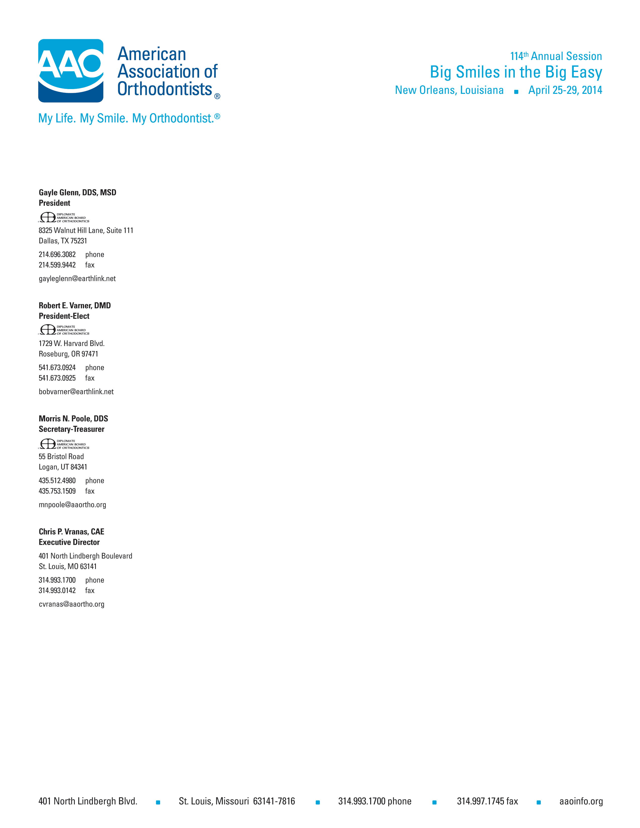

DATE

To Whom It May Concern:

Dr. (Name) or designated members of his/her staff have permission from the American Association of Orthodontists to print the AAO poster [insert name of poster, e.g., “Your Appearance. Your Smile.”].

If you have questions, please contact me at the American Association of Orthodontists, 314-993-1700, ext. 524 or via e-mail at ppaladin@aaortho.org.

Sincerely,

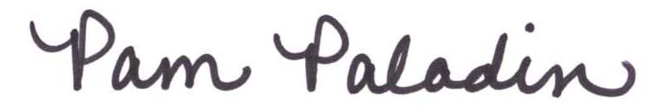

Pam Paladin  
Marketing and Member/Consumer Relations Manager