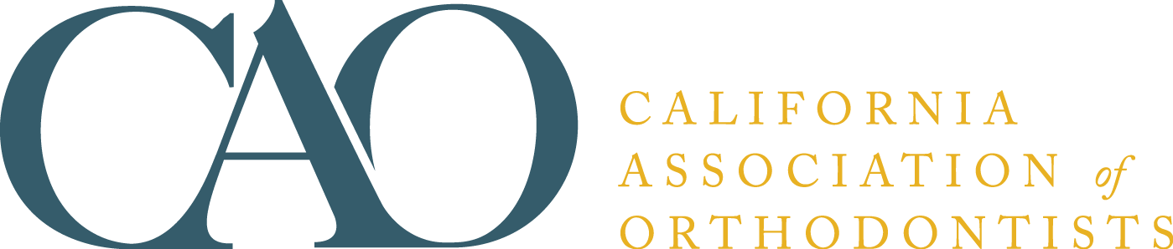

CAO Orthodontic Assistant Permit (OAP) Staff Training Course

The California Board of Directors is pleased to announce that our CAO Orthodontic Assistant Permit Staff Training Course is ready for distribution. The OAP course encompasses a number of modules requiring 84 hours of instruction for Dental Assistants and 60 hours for RDAs. Once the course, the Dental Board OAP written final examination and the permit application are successfully completed and submitted, the Dental Board will grant the applicant an Orthodontic Assistant Permit.

Additional Staff Member Pricing
CAO Members: $25 per assistant trained
Non-CAO Members: $50 per assistant trained
Non-CDA Members: $50 per assistant trained

Payment Method:  MasterCard  Visa  American Express
Provider Name
Street address, City, State & Zip
Phone
Email:
Name as it appears on the card
Card #
Expiration Date

Please list first and last name of all assistants to be trained:

California Association of Orthodontists
401 N Lindbergh Blvd
St. Louis, MO 63141-7816
(888) 242-3934
Fax: (314) 993-6992
krichardson@aaortho.org

